Report to |  | On
Planning Committee |  | 4 March 2021Thursday, 4 March 2021
Title |  |  |  | Portfolio Holder |  | Report of
Planning Application received by Lancashire County Council (South Ribble Ref: LCC/07/2021/00012) -  Land to the north and south banks of the River Ribble |  |  |  | Cllr Evans |  | Director of Planning and Property

Is this report confidential? | No

Purpose of the Report
- This report seeks resolution from the Planning Committee as to what response is provided to LCC in relation to the planning application for the River Ribble flood risk management works- currently under consideration.

Recommendations
- That Members raise no objection in principle to the proposal but that LCC consider the following aspects:

- A commitment to continued discussion with Penwortham Town Council and South Ribble about the open space provision at Ribble Sidings.

- Further consideration is given to the final design of the replacement flood defence wall at Riverside Road.

Reasons for recommendations
- The principle of the scheme is acceptable as it addresses flood risk management. Further consultation with relevant bodies on the Ribble Sidings would enable different suggestions to be considered.

Other options considered and rejected
- No other options have been considered as the County Council is seeking our response as a consultee.

Corporate outcomes
- The report relates to the following corporate priorities: (tick all those applicable):

An exemplary council |  | Thriving communities | x
A fair local economy that works for everyone |  | Good homes, green spaces, healthy places | x

Background to the report
- The planning application was received by LCC in December 2020 with all documentation available to view on the County Council’s website http://planningregister.lancashire.gov.uk (using the LCC ref. LCC/2021/00021). The Case Officer dealing with the planning application has confirmed that the earliest County Planning Committee that the application can be taken for determination is the meeting scheduled for 21 April 2021.

The Proposed Development
- The Environment Agency (EA) has identified a programme of works to improve flood risk management associated with the River Ribble and some of its tributaries. The Preston & South Ribble Flood Risk Management Scheme (FRMS) seeks to reduce the high level of flood risk to approximately 4,778 properties including over 500 businesses along the Rivers Ribble and Darwen, to the south of Preston and is split into five areas:

• Area 1: Riversway & Broadgate
• Area 2: Lower Penwortham
• Area 3: Frenchwood & Walton-le-Dale on the Ribble
• Area 4: Walton-le-Dale on the Darwen
• Area 5: Higher Walton

The scheme involves approximately 9 km of replacement or refurbishment of linear defences (walls and earth embankments) adjacent to the River Ribble which includes 1.5 km of new defences on the River Darwen. The proposed solution is a combination of raised linear defences including embankments, solid walls and glass panels. The heights of the existing defences range from 0.5m to approx. 1.4m, the maximum height of the proposed defences is around 3m. The EA are proposing to install glass panels above 1.4m in locations where there will be significant visual impacts. Several potential areas have been identified within the Scheme study area, for the creation of wetland habitat.

The current application relates to Area 1 Riversway and Broadgate and Area 2 Lower Penwortham.
This report focuses on Area 2: Lower Penwortham: Area 2 is located on the left (south) bank of the River Ribble, to the south of Preston city centre. This area is approximately 0.8km long, extending from the old railway embankment around Penwortham Methodist Church to Penwortham Old Bridge. It then runs upstream along the left bank of the River Ribble to the West Coast Main Line (WCML).

It includes the raising and/or modification of existing defences, bank stabilisation work, combined with the utilisation of glass panels to reduce the impact on views over the river corridor. Area two has been subdivided to sub sections.
Area 2A
• A new pre-cast concrete flood wall totalling 174m in length to replace the existing fence around Penwortham Methodist Church ranging between 0.4m and 2.47m. In order to maintain security of the allotments, fencing will be installed along the top of the new wall to ensure that a minimum height of 1.8 m is maintained around whole length of the wall;
• New road ramp to raise existing road levels by approximately 1.0 m at the entrance to Penwortham Methodist Church; and
• New ramp 8m long and 1.3m in height along the path that cuts through the disused railway embankment into the Penwortham Residential Park.
Area 2B
- New 8m long 1.73m high concrete flood wall extending upstream from the Cadent Gas pipe bridge;
- New 191m long pre-cast concrete flood wall ranging between 1.90m and 2.31m in height, incorporating 0.6m and 0.8m high glass panels, extending along Riverside Road upstream from the Cadent Gas pipe bridge to Stanley Avenue;
- Installation of a 60m long revetment on the wet-side of the new flood wall upstream of Riverside Road;
- New 155m long pre-cast concrete flood wall ranging between 0.4m and 1.53m high along the river front linking Riverside Road to Ribble Sidings; and
- Removal of the existing 1.7m high flood defence embankment at Ribble Sidings and construction of a new 162m long 3.87m high flood defence embankment with a 3m wide crest and 1 in 3 gradient side slopes. The existing riverside footpath (NCR 55 and Prow 7-9-BW34) will be maintained with an access ramp over the proposed flood defence embankment.
- Landscape improvements to the open space area known as Ribble Sidings

Area 2C

- Partial infilling of a 30m long underpass under the WCML to the south east of Margaret Road, utilising foamed concrete and Redi-Rock blocks.

Considerations
Three considerations for South Ribble Borough Council, are:
- What is the visual impact of the proposals on the residents and local area?
- What is the impact upon Heritage assets?
- What mitigation is proposed?
Visual Impact
The proposed works would have an impact upon the character and appearance of the area and of the residential amenity of the adjacent properties particularly to Riverside Road. The scheme details provide for a pre cast concrete wall with a glass panel to mitigate the Impact- the glass panels will enable views to be retained- Appendix 2 provides a photomontage. During the site visit with the EA it was agreed that further consideration should be given to incorporate some relief within the design of the wall, particularly at Riverside Road to help break up the long length of wall.
Heritage Assets
A Heritage Statement accompanies this application and assesses the proposed Scheme’s impact on 15 heritage assets. It confirms that Listed Building Consent will be required for works associated with the Railway Viaduct over River Ribble; and Penwortham Old Bridge, which is also a Scheduled Monument and as such will also require Scheduled Monument Consent. The EA has verbally confirmed that most of these works would take place within Preston City Council. In summarising the overall impact of the proposed scheme on the identified heritage assets, the Heritage Statement concludes that negligible to minor temporary and negligible to minor permanent impacts are assessed on two medium value assets; Avenham Conservation Area and the Viaduct over River Ribble and on two high value assets; Miller Park and Penwortham Old Bridge. The significance of effect of these impacts (both temporary and permanent) is assessed to be slight to neutral. As such, these are not considered significant (moderate or above effects) and equate to less than substantial harm as defined in the NPPF Paragraphs 193 to 197.

Mitigation and Enhancement
Mitigation measures will be required in order to avoid, reduce, remedy or compensate for any adverse landscape or visual effects of the proposed Scheme in accordance with planning and environmental policy. The applicant has held discussions with the Council and the enhancement proposals identified include, but are not limited to, the following:
- Enhancements within open space at the end of Hawkhurst Road to include new footpath routes, tree and shrub planting;
- Ecological and landscape enhancements at Ribble Sidings;
- Interpretation boards located along the river banks relating to heritage features such as the old railway line and the Penwortham ferry crossing;
- Tree planters and seating along Riverside and near Penwortham Old Bridge to enhance the street scene and Preston Guild Wheel route;

Trees to be protected or removed will be agreed with the relevant local authority prior to construction. The applicant has advised that all lost ornamental and screening vegetation will be replanted and trees lost will be replaced at a 5:1 ratio.
It will not always be possible to replant trees back in the same location due to site constraints, including the new defences, underground services, and extensive hardstanding that is to be reinstated. Trees will be replanted in local areas such as Ribble Sidings and the green space adjacent to the Golden Way footpath. In addition, sites for tree planting have been identified along Fishwick Bottoms to help deliver the five to one tree replacement target.
A scheme has been put forward for the design of the landscape Improvements at Ribble Sidings however, further discussions are taking place.
Construction

Construction activities relating to the flood defences is anticipated to commence in September 2021 following preconstruction mobilisation and the application for site specific consents and licences. It is anticipated that construction will be completed by March 2023, including all planned reinstatement works. Areas 3-5 will commence early 2023 and complete in 2024.

Temporary Works
Temporary construction compounds will be required for the duration of the construction period. For Area 2, lay down areas for the outlying works will include an area to the north west of the Golden Way adjacent to the footpath, amenity grassland of Ribble Sidings, and within the St Mary Magdalene Primary School. The scheme would require some temporary foot path closures for the duration of the scheme.

Risk
- As Lancashire County Council is a joint applicant and the determining body for the application any risks would lie with them and the Environment Agency. South Ribble own some of the land and the appropriate notice has been served.

Equality and diversity
- Please summarise the outcome of your Equality Impact Assessment (EIA) and Equality Act implications.

Air quality implications
- To be reported verbally.

Comments of the Statutory Finance Officer
- No comments to make

Comments of the Monitoring Officer
- This is a situation where South Ribble Borough Council is a consultee to a planning application; not the body that determines the application.

- The applicants are the Environment Agency and Lancashire County Council. It will be for the County Council to determine the application.

- Members will see from the body of the report that we are talking about a programme of works intended to improve flood risk management associated with the River Ribble and some of its tributaries.

- Planning officers recommend that we should not object in principle to this application subject to a couple of points.

- In deciding on how to respond to the consultation the final decision rests with members. Clearly the recommendations of officers should be taken into account. When making any recommendations members should act reasonably and have due regard to material planning considerations.

Background documents
The application details using this Ref: LCC/07/2021/00012 can be accessed through the following link: https://publicaccess.southribble.gov.uk/online-applications/

Appendices
Appendix 1 – Flood Defence Interventions
Appendix 2 – Photomontages

LT Member’s Name Jonathan Noad
Job Title Director of Planning and Development

Report Author: | Email: | Telephone: | Date:
Catherine Lewis | C. Lewis | 01772 625411 | 18.02.2021

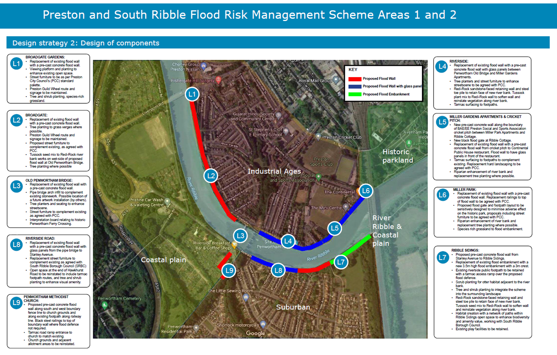
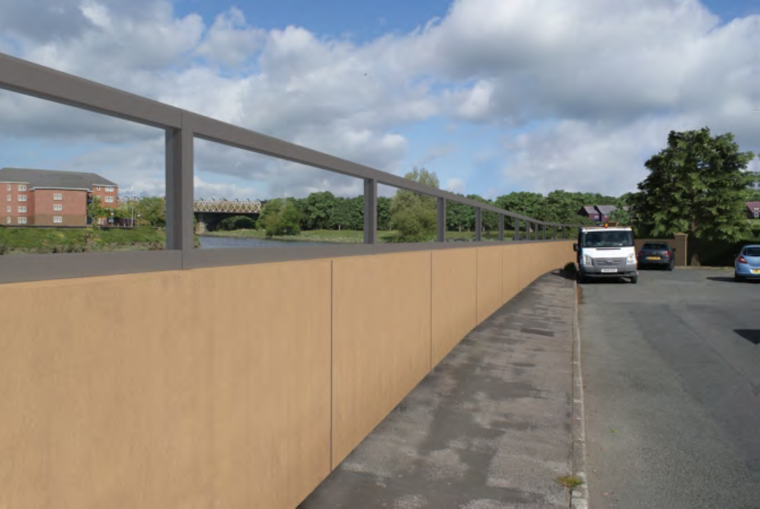
Visualisation of the replacement flood defence, taken from Riverside Road looking upstream towards the West Coast Mainline Viaduct

